|  |
| --- |
| USE [DatabaseName]  GO  /****** Object: Table [dbo].[ProductsDetail] Script Date: 11/27/2022 9:10:58 AM ******/  SET ANSI_NULLS ON  GO  SET QUOTED_IDENTIFIER ON  GO  CREATE TABLE [dbo].[ProductsDetail](  [ProductId] [int] IDENTITY(1,1) NOT NULL,  [ProductName] [varchar](50) NOT NULL,  [ProductSKU] [int] NOT NULL,  [ProductAvaibility] [int] NOT NULL,  [ProductSupplierId] [int] NOT NULL,  PRIMARY KEY CLUSTERED  (  [ProductId] ASC  )WITH (PAD_INDEX = OFF, STATISTICS_NORECOMPUTE = OFF, IGNORE_DUP_KEY = OFF, ALLOW_ROW_LOCKS = ON, ALLOW_PAGE_LOCKS = ON, OPTIMIZE_FOR_SEQUENTIAL_KEY = OFF) ON [PRIMARY]  ) ON [PRIMARY]  GO |

**Sql Script**

Description: Below is the sql script to create **ProductDetail** and **ProductSupplier**

ProductDetail

**Sample for ProductDetail**

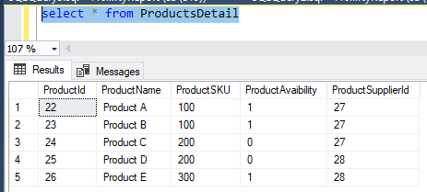

**ProductSupplier**

|  |
| --- |
| USE [DatabaseName]  GO  /****** Object: Table [dbo].[ProductSupplier] Script Date: 11/27/2022 9:13:41 AM ******/  SET ANSI_NULLS ON  GO  SET QUOTED_IDENTIFIER ON  GO  CREATE TABLE [dbo].[ProductSupplier](  [SupplierId] [int] IDENTITY(1,1) NOT NULL,  [SupplierName] [varchar](50) NOT NULL,  [Email] [varchar](255) NOT NULL,  [PhoneNumber] [varchar](255) NOT NULL,  PRIMARY KEY CLUSTERED  (  [SupplierId] ASC  )WITH (PAD_INDEX = OFF, STATISTICS_NORECOMPUTE = OFF, IGNORE_DUP_KEY = OFF, ALLOW_ROW_LOCKS = ON, ALLOW_PAGE_LOCKS = ON, OPTIMIZE_FOR_SEQUENTIAL_KEY = OFF) ON [PRIMARY]  ) ON [PRIMARY]  GO |

**Sample for ProductSupplier**

